列表只读修改说明
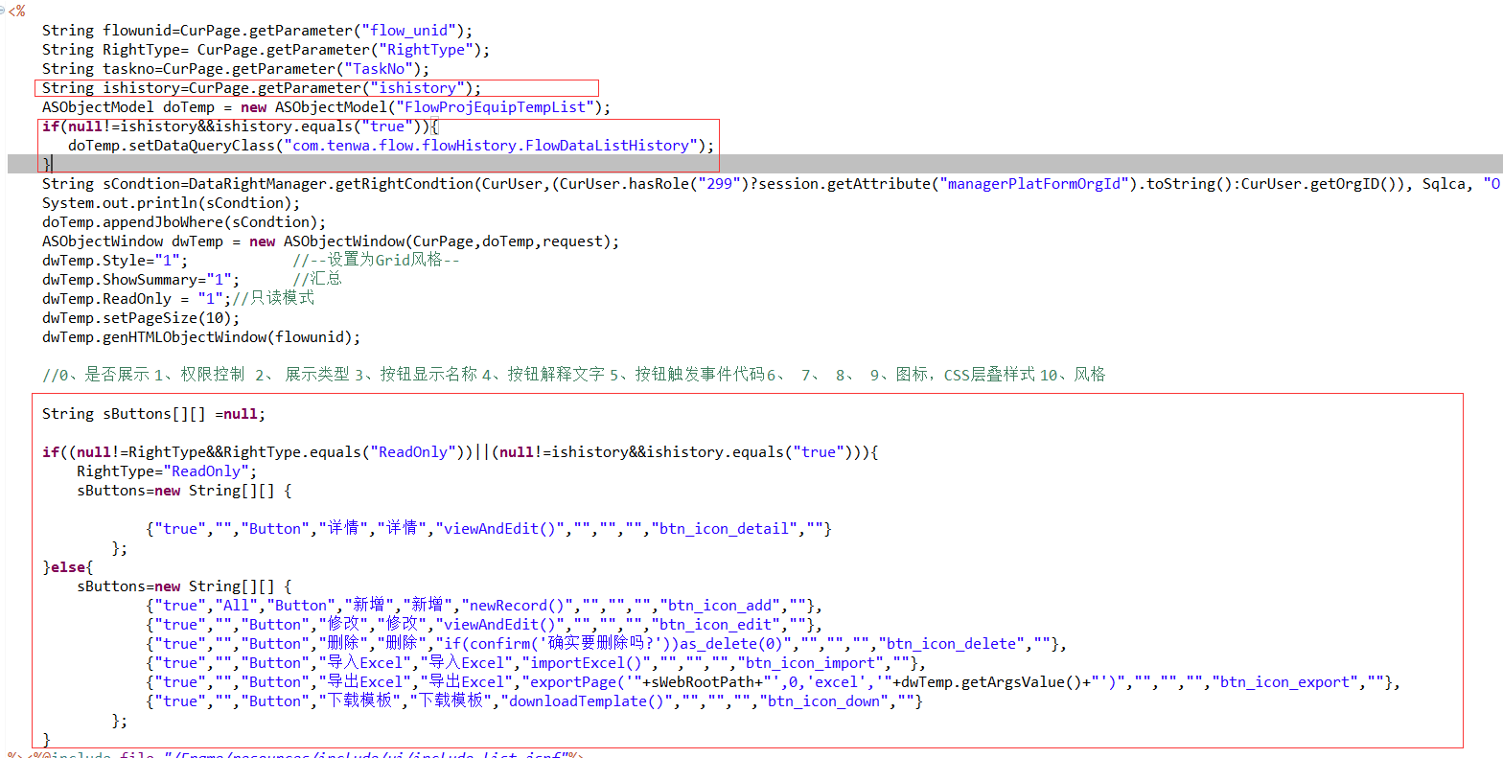
String ishistory=CurPage.getParameter("ishistory");
if(null!=ishistory&&ishistory.equals("true")){
doTemp.setDataQueryClass("com.tenwa.flow.flowHistory.FlowDataListHistory");
}

//0、是否展示 1、 权限控制 2、 展示类型 3、按钮显示名称 4、按钮解释文字 5、按钮触发事件代码 6、 7、 8、 9、图标，CSS层叠样式 10、风格

String sButtons[][] =null;

if((null!=RightType&&RightType.equals("ReadOnly"))||(null!=ishistory&&ishistory.equals("true"))){
RightType="ReadOnly";
sButtons=new String[][] {

{"true","","Button","详情","详情","viewAndEdit()","","","","btn_icon_detail",""}
};
}else{
sButtons=new String[][] {
{"true","All","Button","新增","新增","newRecord()","","","","btn_icon_add",""},
{"true","","Button","修改","修改","viewAndEdit()","","","","btn_icon_edit",""},
{"true","","Button","删除","删除","if(confirm('确实要删除吗?'))as_delete(0)","","","","btn_icon_delete",""},
{"true","","Button","导入Excel","导入Excel","importExcel()","","","","btn_icon_import",""},
{"true","","Button","导出Excel","导出Excel","exportPage('"+sWebRootPath+"',0,'excel','"+dwTemp.getArgsValue()+"')","","","","btn_icon_export",""},
{"true","","Button","下载模板","下载模板","downloadTemplate()","","","","btn_icon_down",""}
};
}
LIST中按钮传参的处理
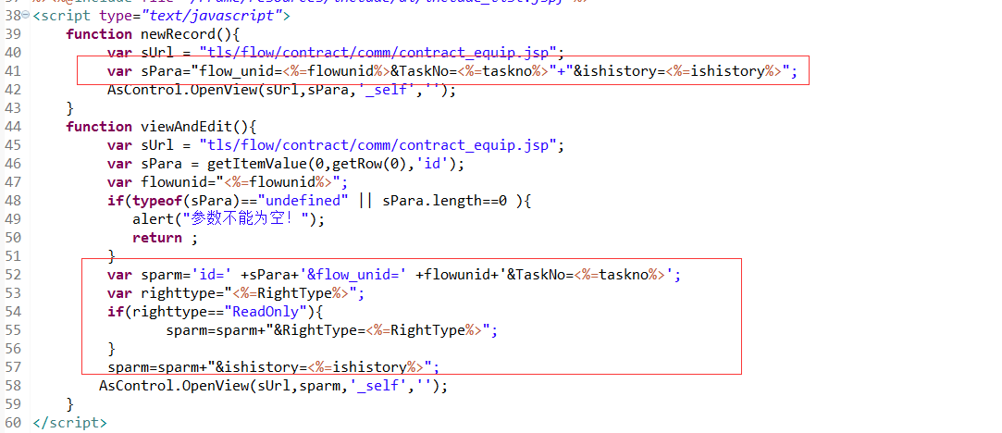

<script type="text/javascript">
function newRecord(){
var sUrl = "tls/flow/contract/comm/contract_equip.jsp";
var sPara="flow_unid=<%=flowunid%>&TaskNo=<%=taskno%>"+"&ishistory=<%=ishistory%>";
AsControl.OpenView(sUrl,sPara,'_self','');
}
function viewAndEdit(){
var sUrl = "tls/flow/contract/comm/contract_equip.jsp";
var sPara = getItemValue(0,getRow(0),'id');
var flowunid="<%=flowunid%>";
if(typeof(sPara)=="undefined" || sPara.length==0 ){
alert("参数不能为空！");
return ;
}
var sparm='id=' +sPara+'&flow_unid=' +flowunid+'&TaskNo=<%=taskno%>';
var righttype="<%=RightType%>";
if(righttype=="ReadOnly"){
sparm=sparm+"&RightType=<%=RightType%>";
}
sparm=sparm+"&ishistory=<%=ishistory%>";
AsControl.OpenView(sUrl,sparm,'_self','');
}

INFO页面只读
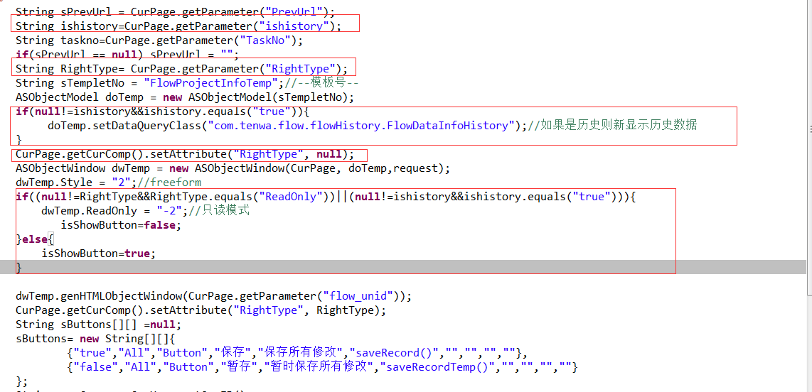
String ishistory=CurPage.getParameter("ishistory");

String RightType= CurPage.getParameter("RightType");

if(null!=ishistory&&ishistory.equals("true")){
doTemp.setDataQueryClass("com.tenwa.flow.flowHistory.FlowDataInfoHistory");//如果是历史则新显示历史数据
}
CurPage.getCurComp().setAttribute("RightType", null);

if((null!=RightType&&RightType.equals("ReadOnly"))||(null!=ishistory&&ishistory.equals("true"))){
dwTemp.ReadOnly = "-2";//只读模式
isShowButton=false;
}else{
isShowButton=true;
}

CurPage.getCurComp().setAttribute("RightType", RightType);

Info页面的返回按钮的处理
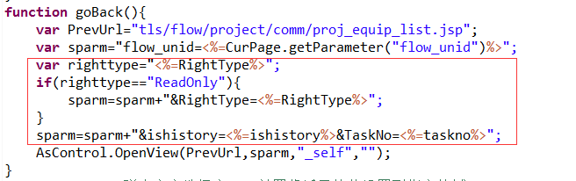

function goBack(){
var PrevUrl="tls/flow/project/comm/proj_equip_list.jsp";
var sparm="flow_unid=<%=CurPage.getParameter("flow_unid")%>";
var righttype="<%=RightType%>";
if(righttype=="ReadOnly"){
sparm=sparm+"&RightType=<%=RightType%>";
}
sparm=sparm+"&ishistory=<%=ishistory%>&TaskNo=<%=taskno%>";
AsControl.OpenView(PrevUrl,sparm,"_self","");
}

